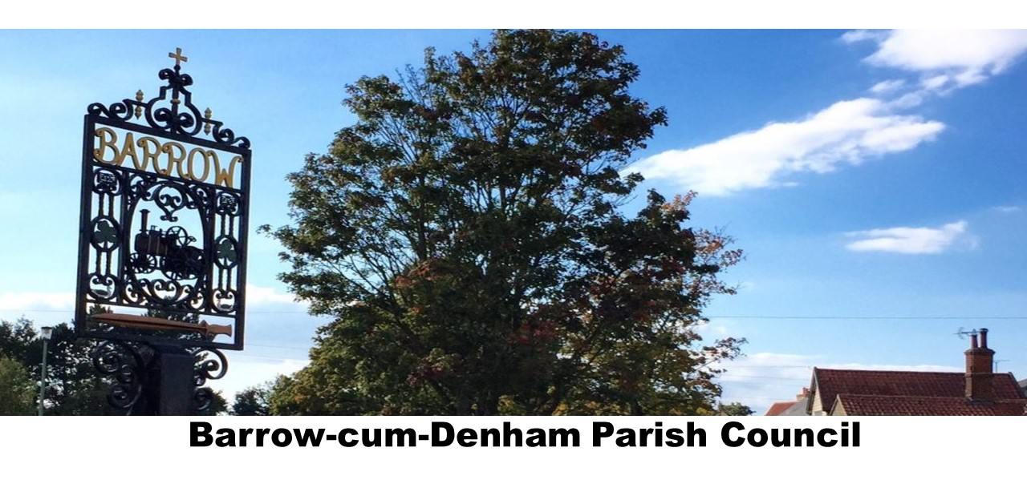

VACANCY

FOR A STREET CLEANER

Please contact:
Barrow cum Denham Parish Council
barrowcumdenhampc@gmail.com
07795 343576

